**Assignment**

#### Goal

#### Currently application code is staged into GitHub repository and the requirement is to migrate the code to Bit Bucket repository.

#### ****Pre-Requisites****

1. Github Repo: <https://github.com/dptrealtime/java-login-app.git>
2. Create two Bitbucket  accounts to follow the best practices (Developer1 & Developer2 accounts)
3. Create private Bitbucket repository and add Developer1 and Developer2 as collaborators.

#### Migration

1. Clone GitHub repository
2. Clone Bitbucket repository as Developer1
3. Migrate the code from Github repository (local master) to Bitbucket repository (local master)
4. Follow branching strategy and commit the code to “feature” branch of Bitbucket repository.
5. Raise Pull Request to merge the code from Feature branch to Master branch and add Developer2 as reviewer.
6. Login to Bitbucket as Developer2 then approve and merge the PR using “no fast forward”  merge strategy.

#### Verification

#### Verify that the code is now showing in the Bitbucket repo.

**Pre-Requisites**

1. **GitHub Repo:** <https://github.com/dptrealtime/java-login-app.git>
2. **Create two Bitbucket accounts to follow the best practices (Developer1 & Developer2 accounts)**

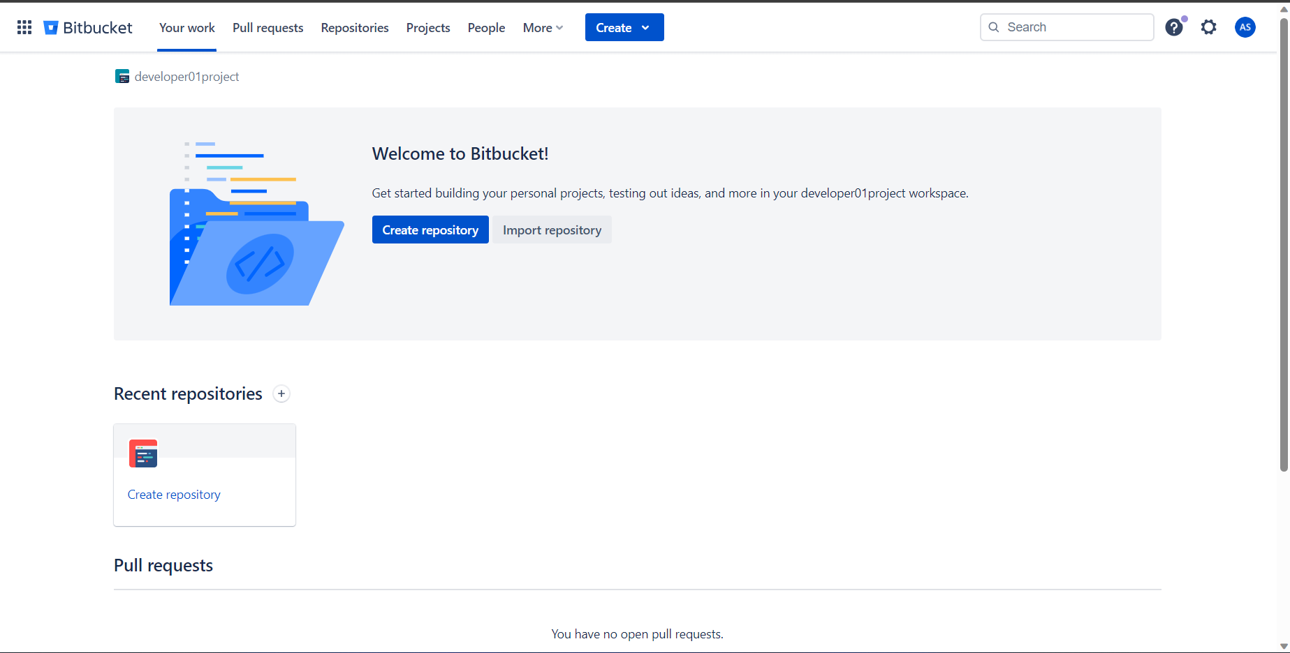

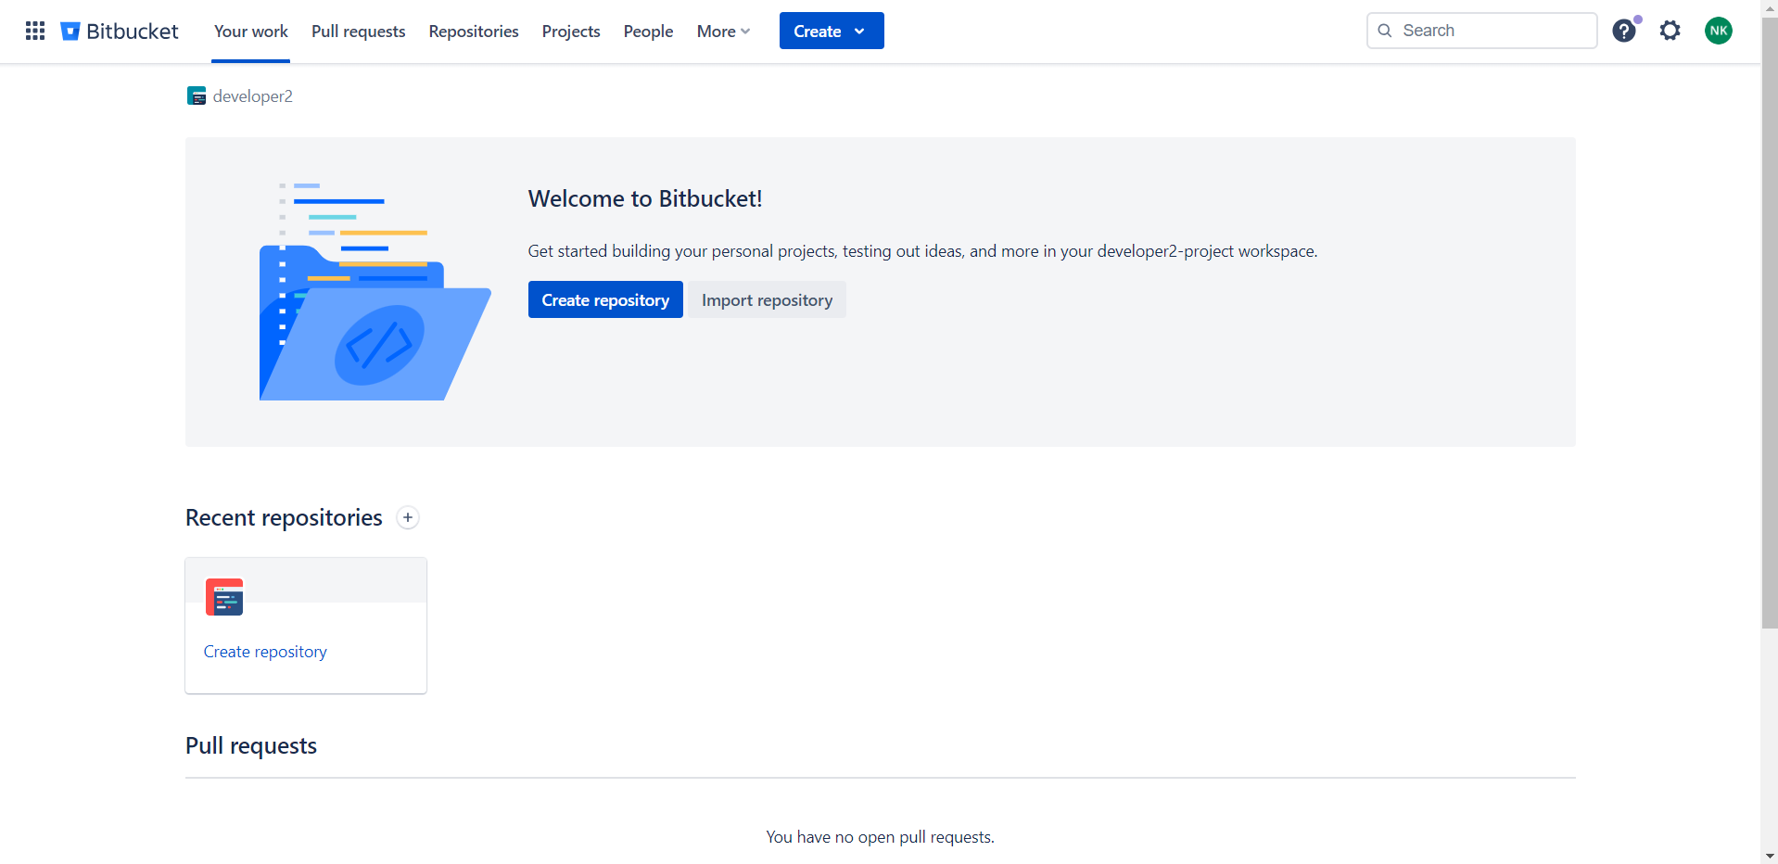

1. **Create private Bitbucket repository and add Developer1 and Developer2 as collaborators.**

Create a blank repository on developer1’s account. The bitbucket repo name should preferably be the same as the existing github repo name

**Migration:**

1. **Clone GitHub repository**

**Cloned and renamed the downloaded working directory name**

git clone <https://github.com/dptrealtime/java-login-app.git>

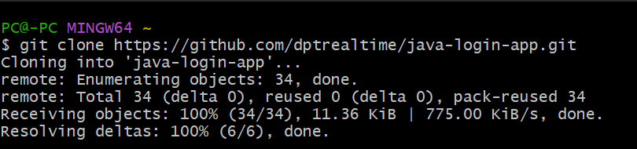

mv java-login-app/ java-login-app_original

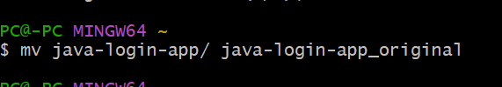

1. **Clone Bitbucket repository as Developer1**

git clone <https://agberasamson@bitbucket.org/developer01project/java-login-app.git>

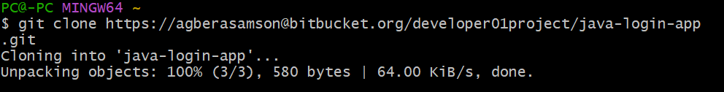

1. **Migrate the code from GitHub repository (local master) to Bitbucket repository (local master)**

Deleted unneeded .git folder in original local repo and copied the code to the new bitbucket local working directory

$ cd java-login-app_original/

$ rm -rf .git/

$ cp -r * ../java-login-app/

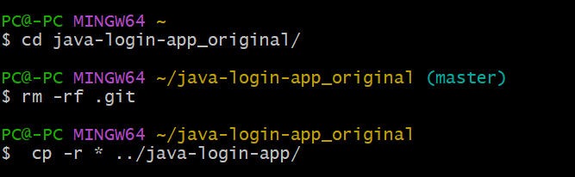

1. **Follow branching strategy and commit the code to “feature” branch of Bitbucket repository.**

In bitbucket working directory, created and checked out to feature branch. Committed the changes and pushed them to developer 1’s bitbucket account

$ cd

$ cd java-login-app

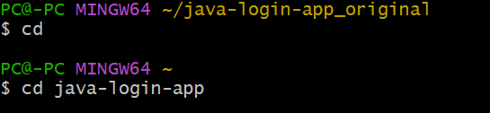

$ git checkout -b feature

Switched to a new branch 'feature'

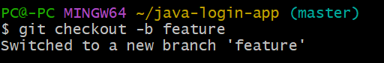

$ git config user.name "developer1"

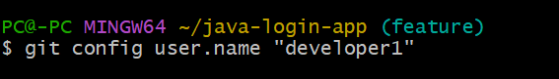

$ git config user.email [agbersamson@gmail.com](mailto:agbersamson@gmail.com)

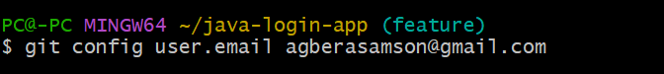

$ git add . && git commit -am "commit #1 in feature branch"

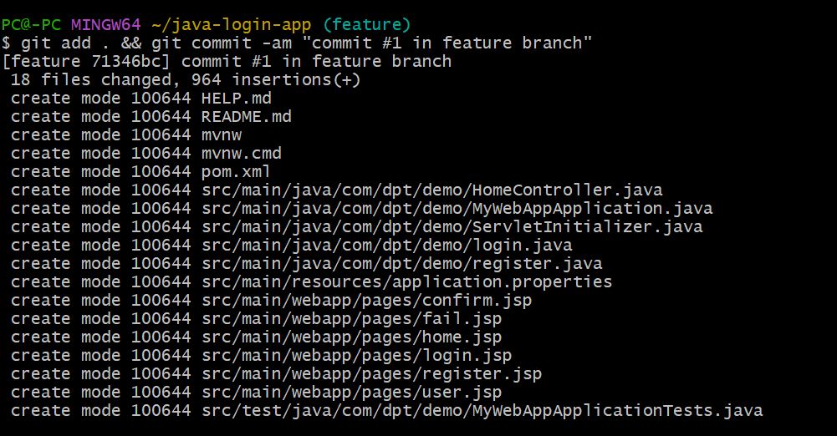

$ git remote -v

origin https://yemisiodunade@bitbucket.org/yemisiodunade/java-login-app.git (fetch)

origin https://yemisiodunade@bitbucket.org/yemisiodunade/java-login-app.git (push)

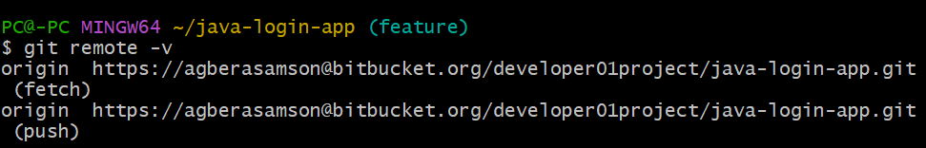

$ git push origin feature

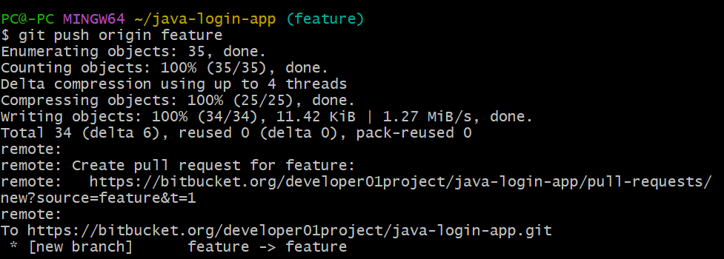

***Feature branch commit shown here***

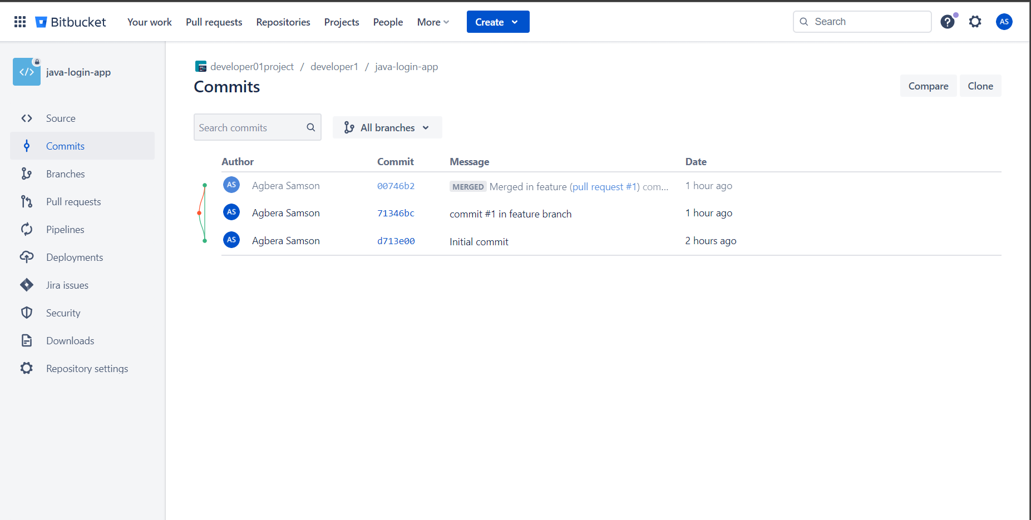

1. **Raise Pull Request to merge the code from Feature branch to Master branch and add Developer2 as reviewer.**

***Pull request raised by developer 1 is shown below***

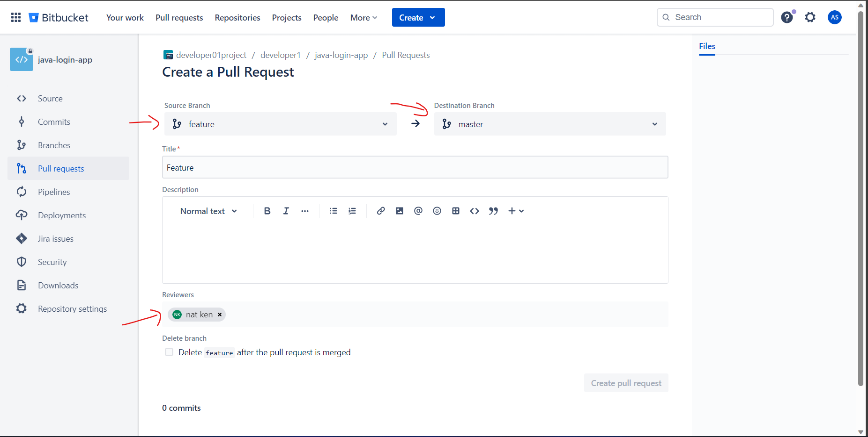

1. **Login to Bitbucket as Developer2 then approve and merge the PR using “no fast forward” merge strategy.**

***Pull request shown in developer 2’s account***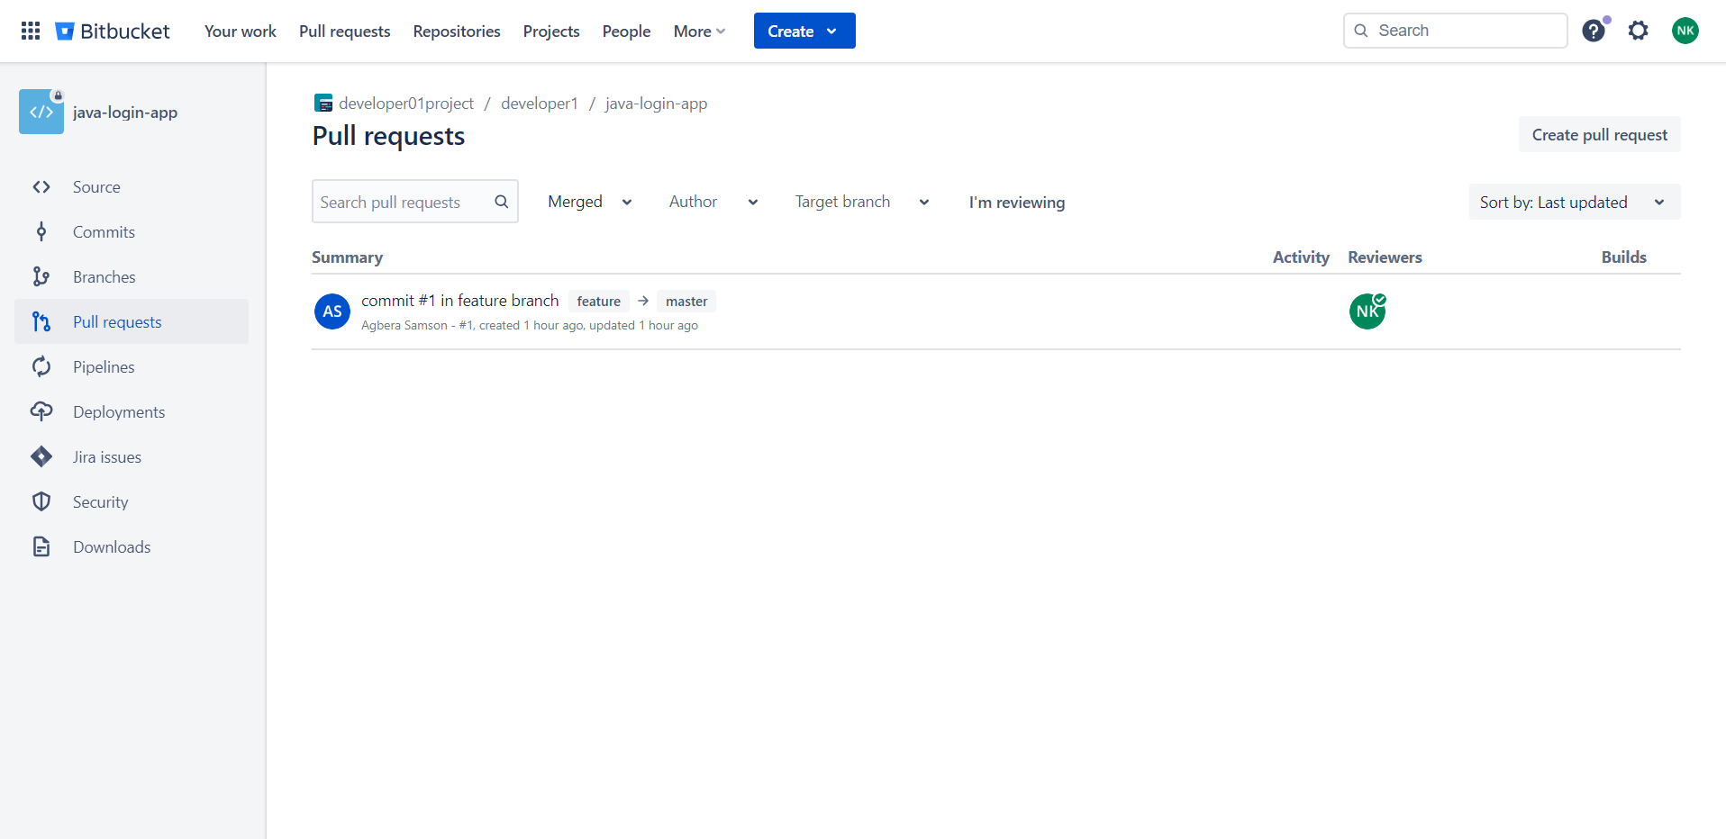

***Pull request was approved and merged using requested strategy***

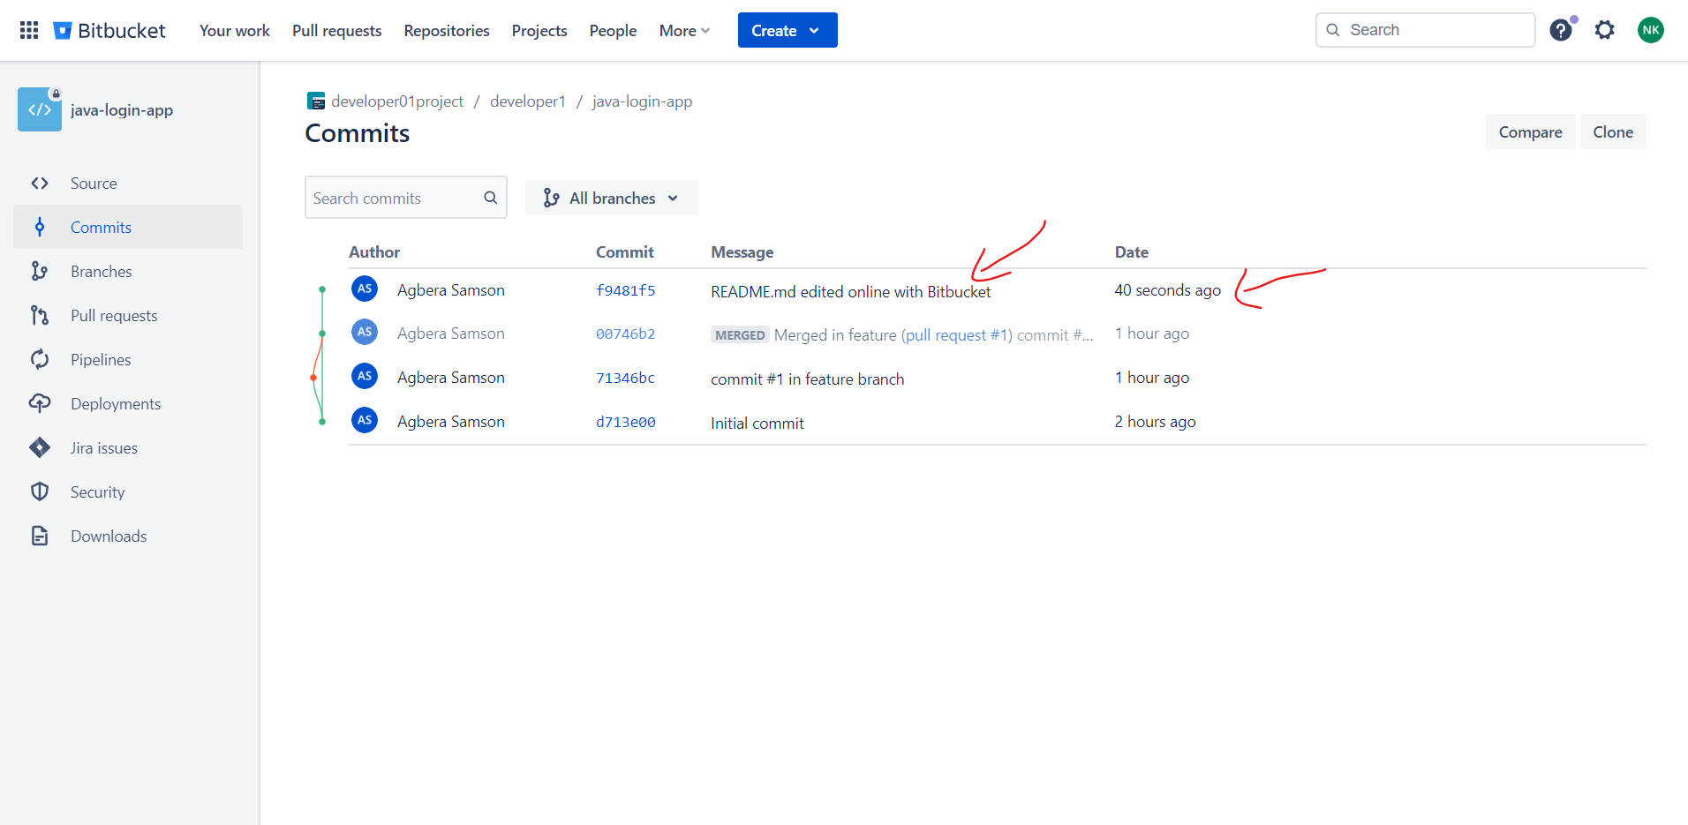

Verification:

**Verify that the code is now showing in the Bitbucket repo.**

**Note: Explore various other options to migrate the code from Github to Bitbucket and add the possibilities in the comments.**

Migrated Code is shown in Bitbucket repo

